From Evangelical Lutheran Hymn-Book (1918)

63
For a Right Knowledge of Christ.

O Almighty God, Whom to know is everlasting life; Grant us perfectly to know Thy Son Jesus Christ to be the way, the truth, and the life; that following His steps we may steadfastly walk in the way that leadeth to eternal life; through the same, Thy Son, Jesus Christ our Lord. Amen.

62
For Likeness to Christ.

Almighty God, Who hast given Thine Only Son to be unto us both a sacrifice for sin and also an ensample of godly life; Give us grace that we may always most thankfully receive that His inestimable benefit, and also daily endeavor ourselves to follow the blessed steps of His most holy life; through the same Jesus Christ our Lord. Amen.

10
For the Church

Grant, we beseech Thee, Almighty God, unto Thy Church, Thy Holy Spirit, and the wisdom which cometh down from above, that Thy Word as becometh it, may not be bound, but have free course and be preached to the joy and edifying of Christ’s holy people, that in steadfast faith we may serve Thee, and in the confession of Thy Name abide unto the end; through Jesus Christ our Lord. Amen.
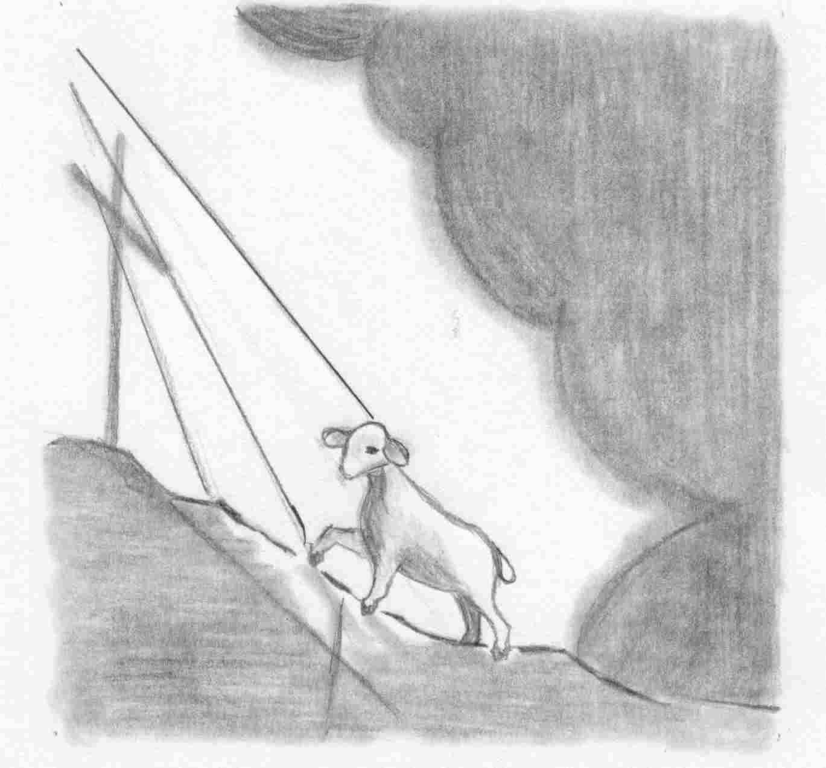
Behold, the Lamb of God,
Who takes away the sin of the world!

Our Redeemer Lutheran Church
403 South Hayes
Emmett, Idaho 83617 Church: 208-365-5231

Pastor: Rev. Michael L. McCoy
parsonage: 208-365-5214
email: mmccoy19@earthlink.net
www.scholia.net – the website for:
Good News for the Diaspora!
Music, Litany and Sermons for the Diaspora!
scholia.net publishing – Where the Word is not Bound
Predici in limba romana – (Sermons in Romanian)
The artwork is by Sharon Geiser. Permission to use this copyrighted graphic is limited to congregational use. The Evangelical Lutheran Hymn-Book (Concordia Publishing House, 1918) is in the public domain.

This bulletin cover provided by www.scholia.net and is made available without cost.

16 January Anno Domini 2005

Epiphany 2
Behold, the Lamb of God,

Who takes away the sin of the world!
To place the graphic on this page:
Copy the graphic on the previous page.
Click on the open space above and a graphic box should appear. Paste the graphic.

Change this frame and the box above by clicking the body of the text and adding the particulars. (See the previous page for an example.)
The artwork is by Sharon Geiser. Permission to use this copyrighted graphic is limited to congregational use. The Evangelical Lutheran Hymn-Book (Concordia Publishing House, 1918) is in the public domain.

This bulletin cover provided by www.scholia.net and is made available without cost.

16 January Anno Domini 2005

Epiphany 2

From Evangelical Lutheran Hymn-Book (1918)

63
For a Right Knowledge of Christ.

O Almighty God, Whom to know is everlasting life; Grant us perfectly to know Thy Son Jesus Christ to be the way, the truth, and the life; that following His steps we may steadfastly walk in the way that leadeth to eternal life; through the same, Thy Son, Jesus Christ our Lord. Amen.

62
For Likeness to Christ.

Almighty God, Who hast given Thine Only Son to be unto us both a sacrifice for sin and also an ensample of godly life; Give us grace that we may always most thankfully receive that His inestimable benefit, and also daily endeavor ourselves to follow the blessed steps of His most holy life; through the same Jesus Christ our Lord. Amen.

10
For the Church

Grant, we beseech Thee, Almighty God, unto Thy Church, Thy Holy Spirit, and the wisdom which cometh down from above, that Thy Word as becometh it, may not be bound, but have free course and be preached to the joy and edifying of Christ’s holy people, that in steadfast faith we may serve Thee, and in the confession of Thy Name abide unto the end; through Jesus Christ our Lord. Amen.

